# DXC DD URL

Below are the ITG and PROD URL.

|  |  |
| --- | --- |
| ITG | <https://dxcddss-itg.itcs.houston.dxccorp.net/> |
| PROD | https://dxcddss-prd.itcs.houston.dxccorp.net/ |

# Log in to DXC DD application

1. Go to ITG or Prod DXC DD application and enter your User ID and password for Global Pass.

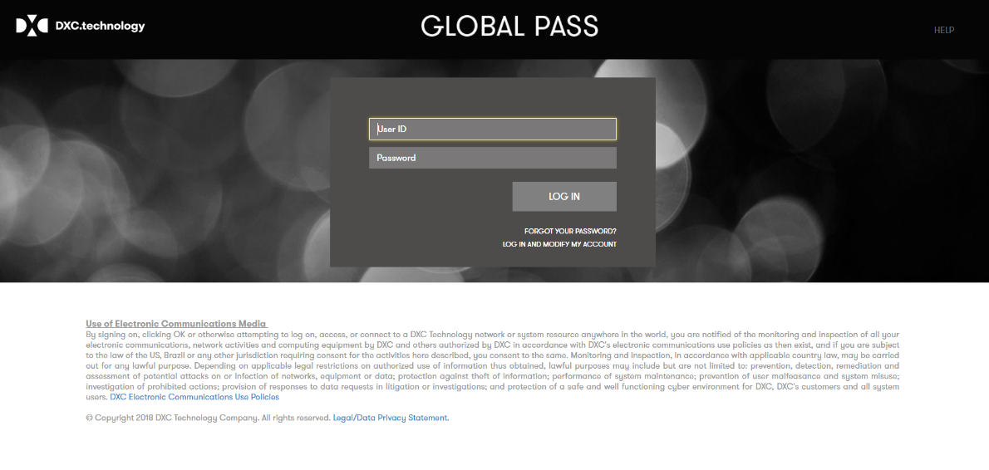

1. Click on Log In button. User will be redirected DXC DD homepage.

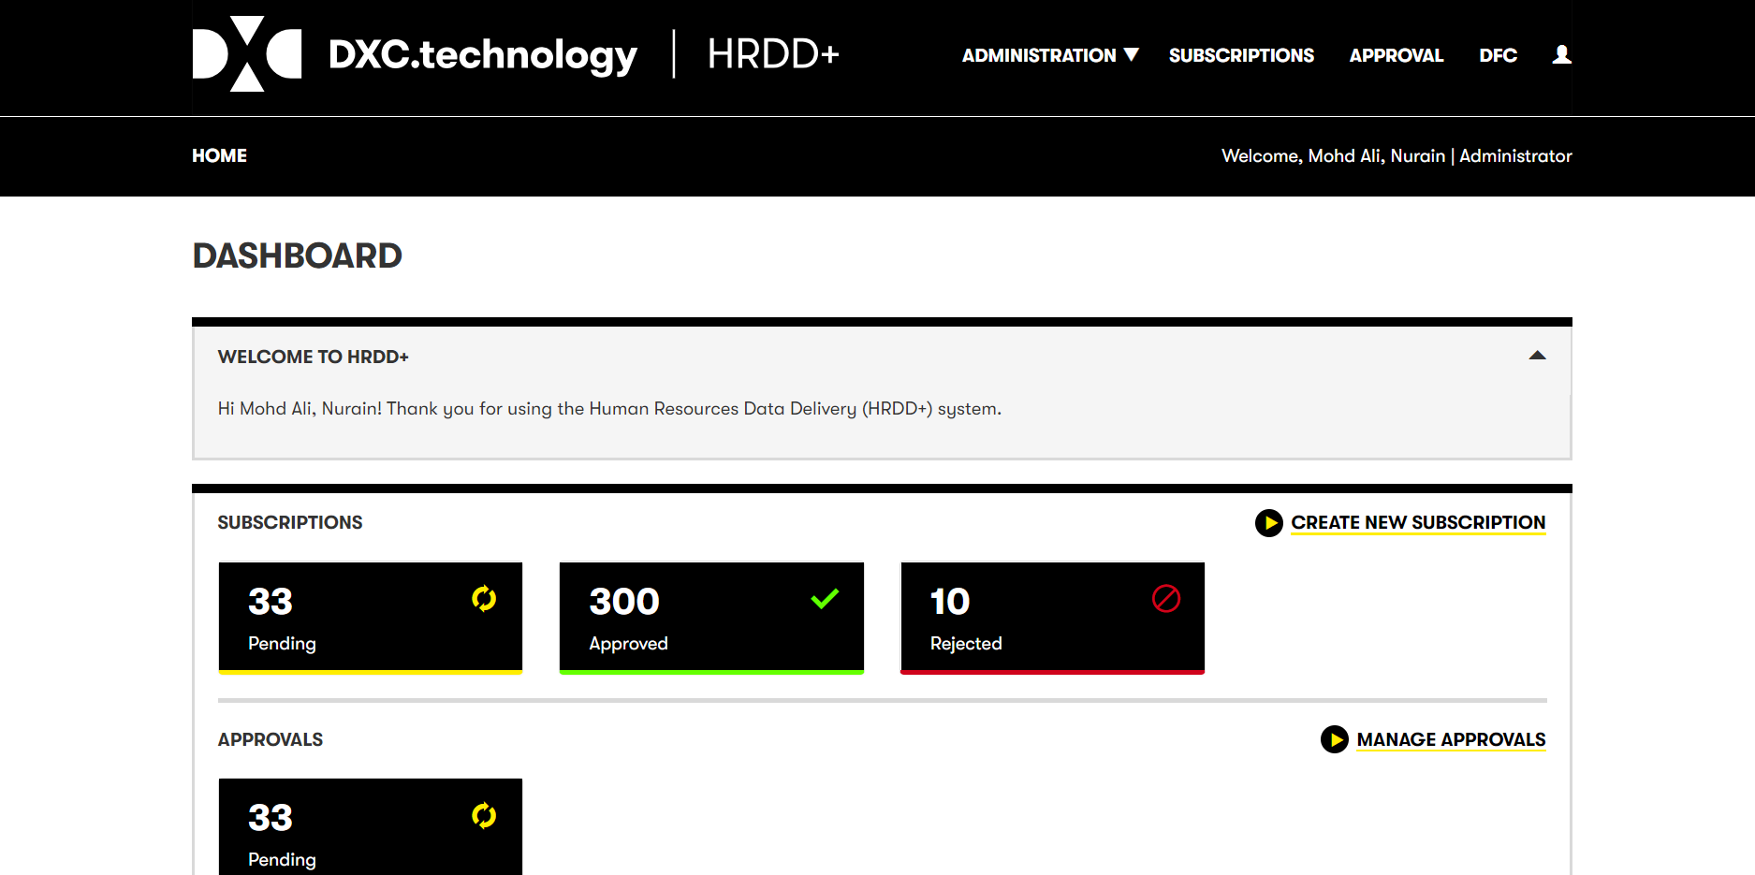

# Subscription

To subscribe RAE /CW Data from HRDD application, you will have to create subscription (s). Below is

the step by step guide to create subscription.

## Subscription to get RAE Employee

1. Once login was successful, click on Subscriptions on the top of the screen.

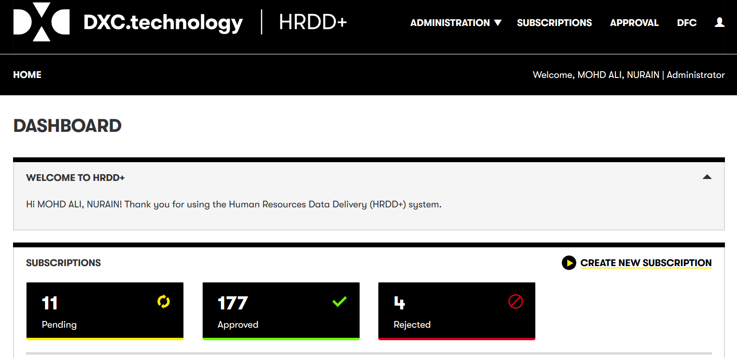

1. User will be redirected to Subscriptions list. Click on “New Subscription” button.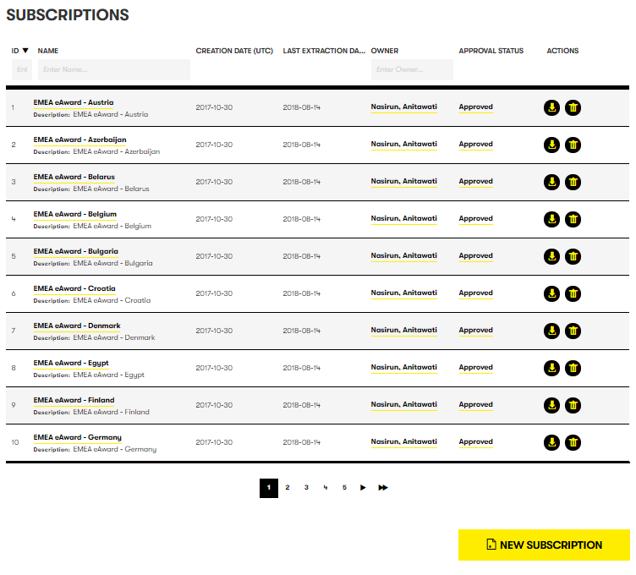
2. Populate the following fields. Then click on Next button.

**Name**: Any unique name of the subscription.

**EPR ID**: EPR ID of your application

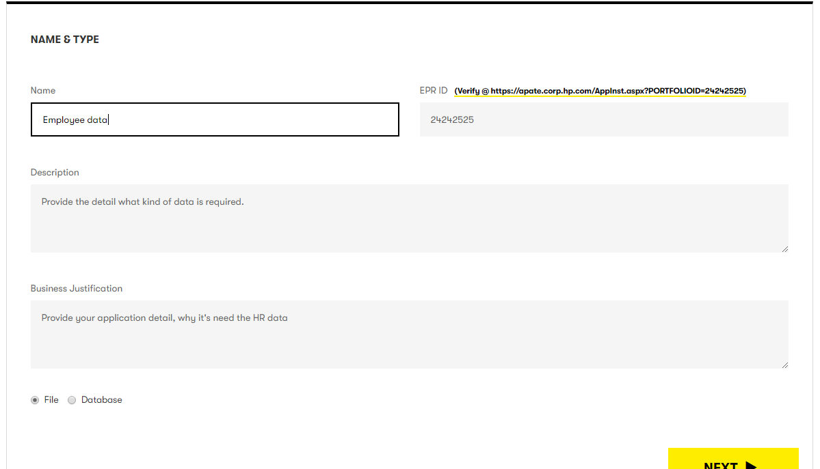

1. Populate the following fields and click on Next button

**Transport Type**: SFTP, if you want to receive file through SFTP. NONE, if you want to receive

through curl download.

**Post Processing**: None

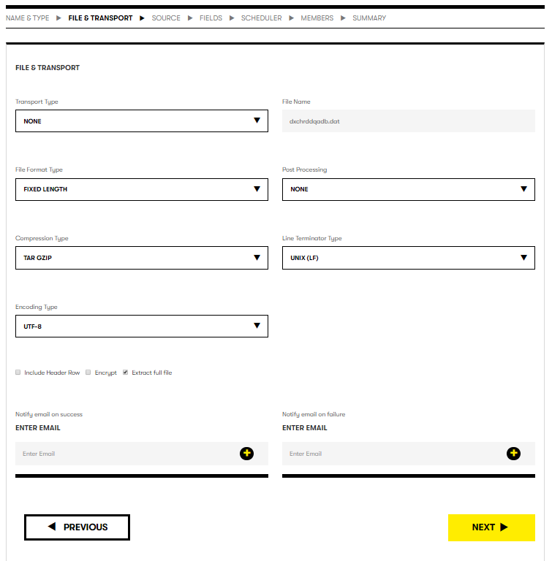

1. Select HRDD in data source and Workday in Data Object. You can see 17 different Object representing one work day file. Each Data Object has set of data fields. Select any one and Click on NEX. In next page you will see data fields. Please go through and select data fields of your choice. For Example select “Consolidated Full Employee Data Feed”. Click Next to continue.

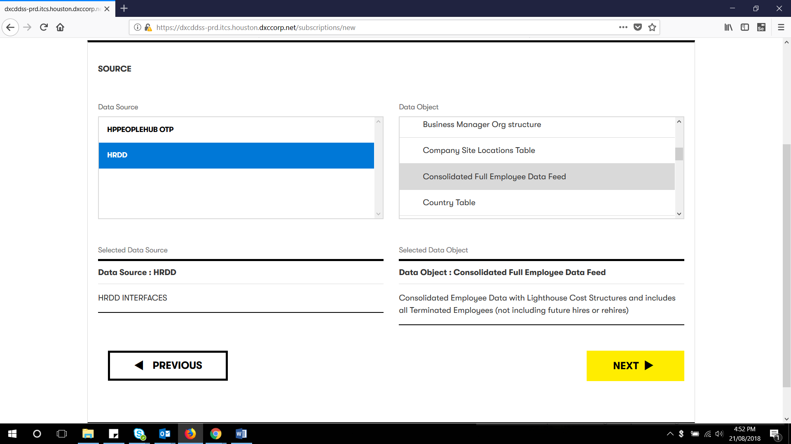

1. Click on the select checkbox for the desire field and click Next button. If required data fields are not in this data object, please click on “Previous” button to go back and select any other Data Object. Note: Data fields of 1 data object only will be part of 1 subscription.

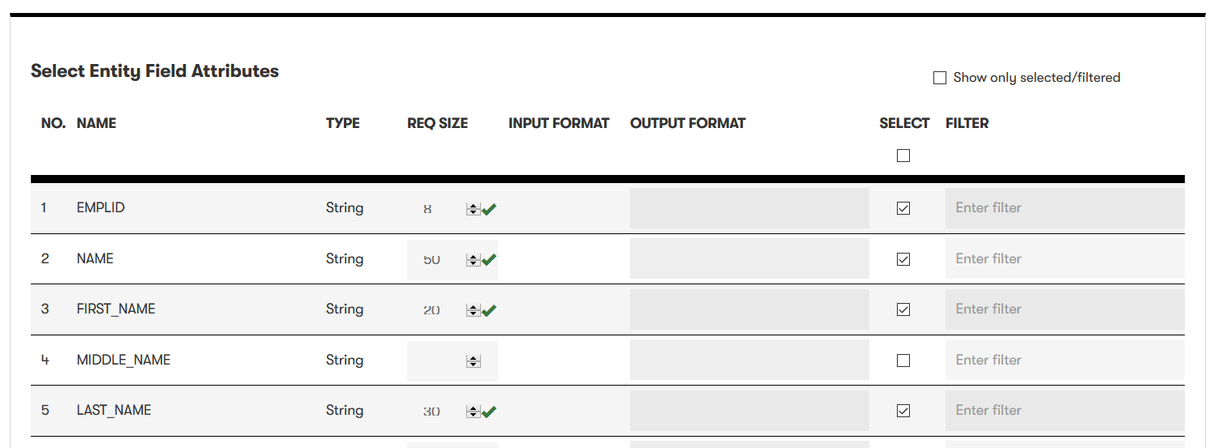

1. Click Add Member button. These will be member, who can login and can check subscription

Status.

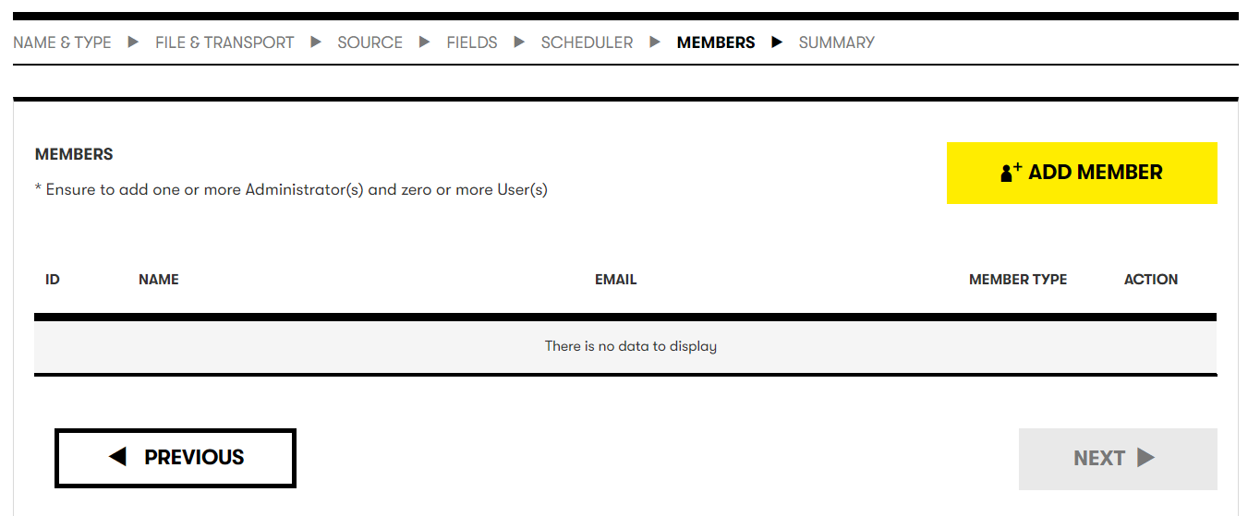

1. Enter an email or name or id to search an employee. Click in add icon and click Close button to continue.

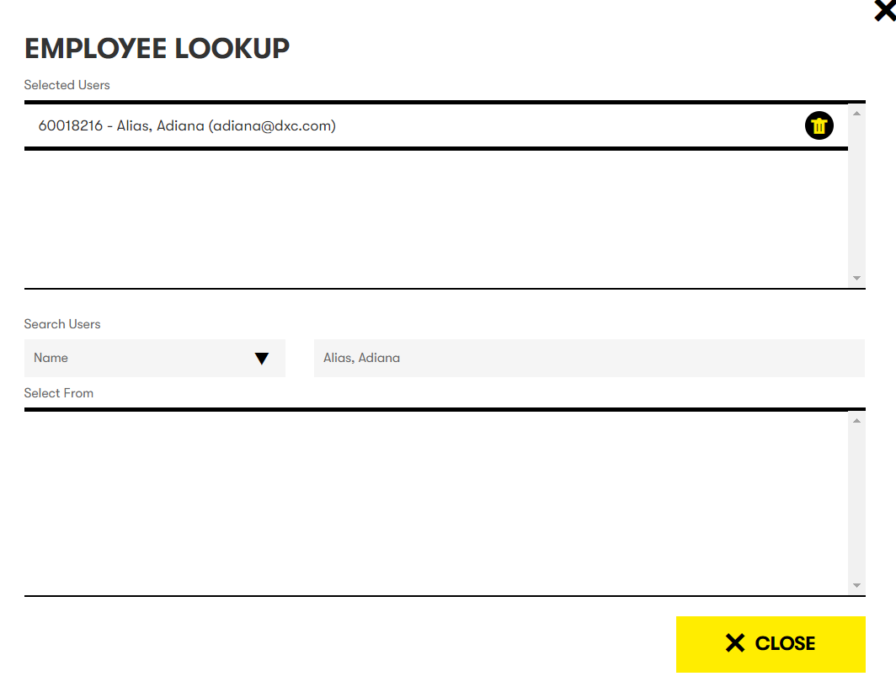

1. Click next button and user will see the summary. Click save button to create the subscription.

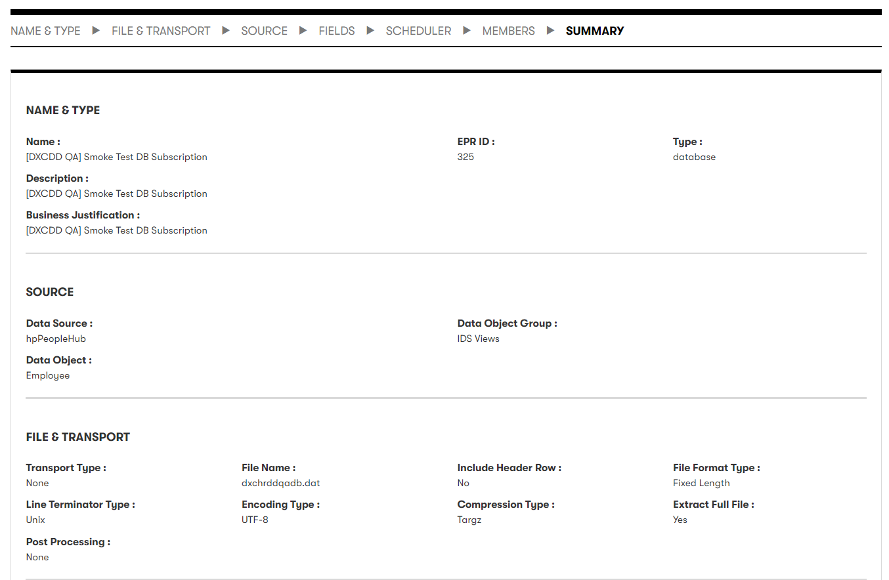

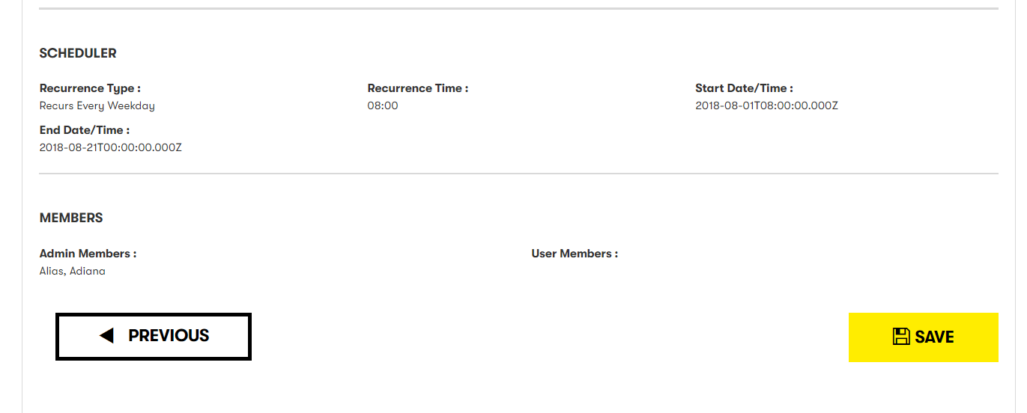

## Subscription to get CWF Employee

1. Once login was successful, click on Subscriptions on the top of the screen.



1. User will be redirected to Subscriptions list. Click on New Subscription button.
2. Populate the following fields. Please choose “Database” type at the bottom of page,because CW data source is Field Glass Database. Then click on Next button.

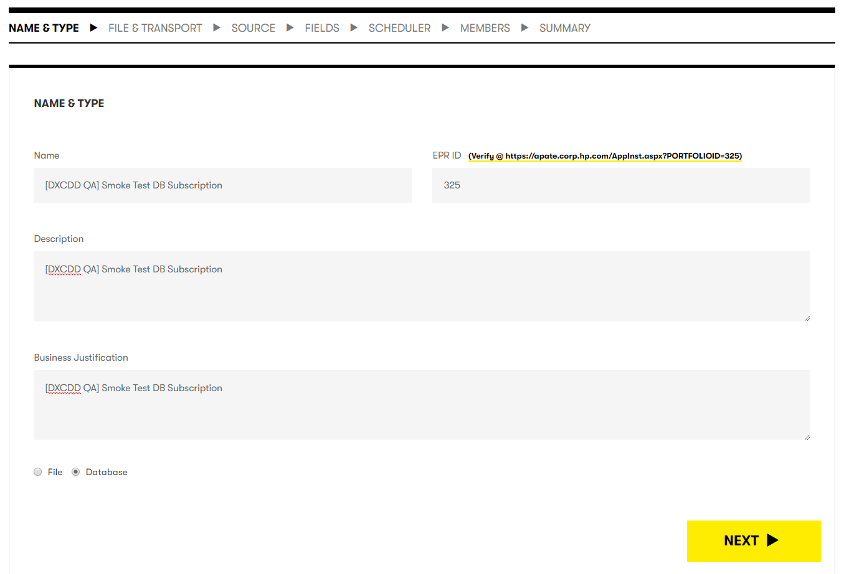

1. Populate the following fields and click on Next button



1. Select GP HUB FIELDGLASS in data source and GPHUB FG in Data Object. There are 2 data objects under GPHUB FG data object. Both has same data. The only difference is that CW Extract (JPN) has few extra data fields. Find and Select CW Extract. Click Next to continue.

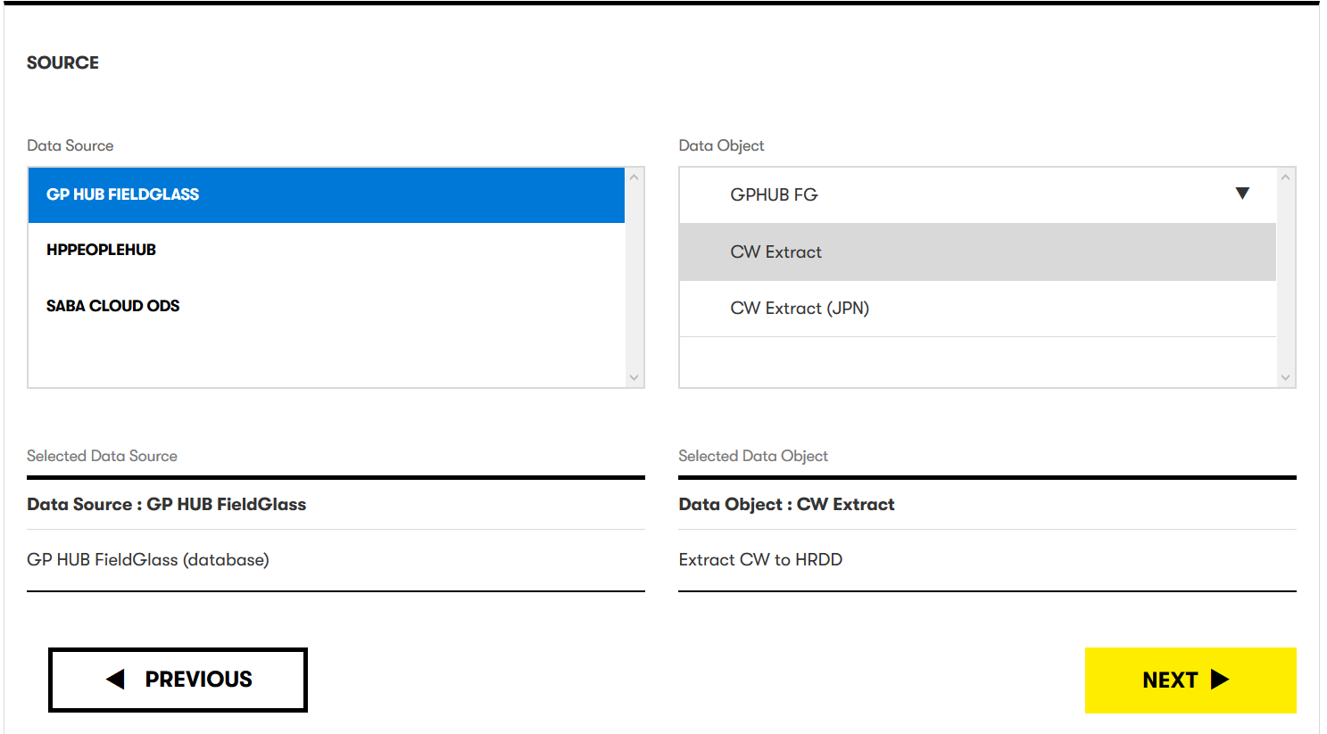

1. Click on the select checkbox for the desire field. Scroll down and click Next button

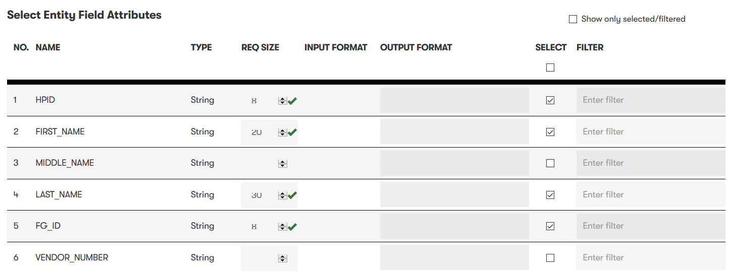

1. Click Add Member button



1. Enter an email or name or id to search an employee. Click in add icon and click Close button to continue.



1. Click next button and user will see the summary. Click save button to create the subscription.



